**Unit 3**

Bioluminescence ﬁrst evolved in the oceans and is sll most common there. Most deep- sea animals have light organs that they use to communicate with each other, aract prey, deter predators, camouﬂage themselves, or dimly illuminate the dark void. Deep-sea bioluminescence is usually blue-green, since only shorter wavelengths travel eﬀecvely through water. Terrestrial bioluminescence evolved later, is much rarer, and is increasingly hard to see in our light-polluted world, but it shines in our own backyards. The larvae and adult females of the seldom-seen glowworm beetle (Phengodidae spp.) are festooned with yellow-green lights. The forests somemes shimmer with so-called foxﬁre, the icy green glow of bioluminescent wood fungi such as the bier oyster mushroom, Panellus spcus. Perhaps foxﬁre was the ulmate origin of the will-o'-the-wisps, those ghost lights that early European selers swore they saw in the swamps and fens of North America. But nothing shines so brightly in the Finger Lakes as the ﬁreﬂies, beetles of the family Lampyridae. Their bioluminescence may have originally evolved as a defense against being eaten and only later adopted as a mang signal. Diurnal animals usually warn predators of their toxicity using bright colors or striking paerns, but only a glowing message stands out in the dark. The mostly nocturnal ﬁreﬂy larvae cull toxic steroids from the slugs and snails that they eat; their lights serve as a menacing public service announcement, as does the sullen glow of the noxious ﬁreﬂy pupa. Adults likewise ﬂash their light organs to warn bats that they are poisonous. Even the eggs of some species luminesce when they are disturbed, like fairy globes hidden in the leaf lier.

**Gecko lizard Feet- Bioinspiration for Adhesive**

Gecko lizards do not have little suction cups on their feet but are able to climb up walls and stick to ceilings. The feet of these animals have toe pads consisting of tiny hair- like structures called setae, made of keratin. The setae are arranged in lamellar patterns and each seta has 400 to 1,000 microhair structures, called spatulae. These tiny structures allow geckos to climb vertical walls or across ceilings. Lizards can cling to hydrophilic or hydrophobic surfaces, although adhesion strength is related to the polarity of the substrate with the more polar the better . Setae range from 30 to 130 mm, and there are 5,000 setae per mm 2 , thus the total number of setae per gecko foot is greater than half a million (Autumn et al., 2000). The size of the spatulae that are attached to the setae ranges from 0.2 to 0.5 mm, distances in which molecular interactions can occur and accounting for van der Waals interactions . The average adhesive force of a seta is ~194 + 25 mN (Autumn et al., 2000). If the average lizard foot is 100 mm 2 , the total adhesive force by a lizard is ~400 N. If a human hand were covered in setae, similar to a gecko lizard, the total adhesive force created from just human hands would be over 30,000 N (equivalent to 6,744 pound-force or 3,059 kg-force).

Mechanism — Geckos use van der Waal forces to adhere to different surfaces and do not use

secreted sticky materials for this function. With such strong adhesive forces the movement of a lizard could be problematic. However, to ‘‘unstick’’ their feet, lizards curl their toes. This movement breaks the van der Waal forces and allows movement across substrates. The critical angle needed to break the forces is 30.68 + 1.8.

Biomimetics — New tapes, similar in design to lizard feet, have been designed and developed as a dry adhesive to eliminate the sticky residue normally left from more traditional tapes and glues. The adhesive sticks to most surfaces. Various microfibers have been synthesized from polyester, silicone, and polyimide materials. Their adhesive forces are 294 + 21 nN per spatula, 181 + 9 nN per spatula, and 70 nN per hair, respectively (Geim et al., 2003). These microfibers adhere in a similar fashion to natural keratinous setae, but after repeated use, the microfibers lose their stickiness due to bunching of the fibers (Geim et al., 2003). Further research studying the traits of chitin microfibers, similar to those found in insects, should help resolve this problem. This type of Gecko-like adhesive could eventually be used for a wide range of applications, from hanging tapestries and rock climbing to wound closure in surgery.

**Whale Fins and turbine blades:**

A 30-tonne humpback whale are huge marine mammals can reach heights of 15 metres as they break through the ocean’s surface, the aerodynamics of their five-metre-long pectoral fins. The front limbs of whales are the largest appendages of any animal on earth, and it is the small bumps called tubercles found along the leading edge that give them their amazing acrobatic skills. These bumps change the way that water flows over the whale’s fins. Scientists at Harvard demonstrated how the hydrodynamic edge works using a mathematical model. They found that these bumps change the distribution of pressure along the pectoral fin and due to this variation, different areas of the fin stall with different angles of attack – making sudden stalls easier to avoid. Researchers at the US Naval Academy, who found that biomimetic fins based on this model reduced drag by a third and improved lift by 30%. They suggested that this could lead to “more-stable aeroplane designs, submarines with greater agility, and turbine blades that can capture more energy from wind or water.”

The unique leading edge of the Humpback whales (Megaptera Novaeangliae) (Figure 1) pectoral flippers that incorporate distinct bumps or “tubercles” might playa role in their feeding process. They noted that the existence of these bumps benefits them with increased manoeuvrability relative to other baleen whales, and their evolutionary adaptation of the “bubble wall hunting” process where small radius turns are especially beneficial for their enhanced feeding success. Humpback whales were found to use their flippers at higher operating angles before stall would occur, which enable it to make very tight turns in manoeuvring to secure their food.

This research is now being applied in the real world by Toronto-based company [Whale Power](https://whalepowercorp.wordpress.com/), who are taking inspiration from these remarkable tubercles to develop wind turbine blades that mimic the pectoral fins of the marine mammals.

The bumpy protrusions, known as tubercles, on the leading edge of humpback whale flippers have already inspired [more efficient wind turbine blades](https://newatlas.com/bumpy-whale-fins-set-to-spark-a-revolution-in-aerodynamics/9020/?itm_source=newatlas&itm_medium=article-body) that are able to produce more power at lower speeds. Now, in a seemingly obvious move, researchers have found that that same principle can be applied to underwater Turbine blades to more efficiently convert low velocity ocean tidal flow energy into electricity.

the wind power blades incorporating tubercle technology pioneered by WhalePower, addition of bumps to the leading edge of underwater turbines made them more effective at harnessing tidal power at low speeds.

Marine scientists have long suspected that humpback whales’ incredible agility comes from the bumps on the leading edges of their flippers. Now Harvard University researchers have come up with a mathematical model that helps explain this hydrodynamic edge. The work gives theoretical weight to a growing body of empirical evidence that similar bumps could lead to more-stable airplane designs, submarines with greater agility, and turbine blades that can capture more energy from the wind and water. 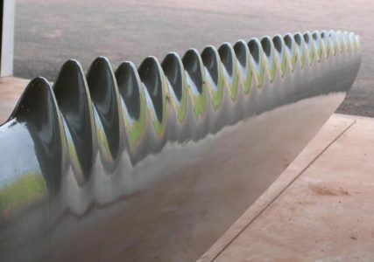

An example of the types of wind turbine blade being developed by Whale Power Corporation that could increase renewable energy sources.

A West Chester University professor has developed a new wind turbine that draws inspiration from a blubbery source: the flippers of a humpback whale. Those knobby flippers were long considered one of the oddities of the sea, found on no other earthly creature.

By studying and mimicking the characteristics of the flippers, fins and tails of whales and dolphins, engineers have devised more a efficient way to generate wind power. The lesson from biomimicry is that unsteady flow and complex shapes can increase lift, reduce drag and delay ‘stall’, a dramatic and abrupt loss of lift, beyond what existing engineered systems can accomplish.

The unique leading edge of the Humpback whales (Megaptera Novaeangliae) (Figure 1) pectoral flippers that incorporate distinct bumps or “tubercles” might play a role in their feeding process. They noted that the existence of these bumps benefits them with increased manoeuvrability relative to other baleen whales, and their evolutionary adaptation of the “bubble wall hunting” process where small radius turns are especially beneficial for their enhanced feeding success. Humpback whales were found to use their flippers at higher operating angles before stall would occur, which enable it to make very tight turns in manoeuvring to secure their food.

In the case of the humpback whale, vortices formed from tubercles (bumps) on the front edge of flippers help to generate more lift without the occurrence of stall, as well as enhancing manoeuvrability and agility.

**Box Fish and Inspiration for Bionic Car:**

A boxfish has certain aero/hydrodynamic features in its body shape which makes it more efficient in traveling through the water using less energy. Because of the streamline features of the boxfish, it produces less drag for its movement. So, there is a lot of possibility to design a passenger car by implementing the aerodynamic features on the car shape for improving the energy efficiency. A box fish is a species of fish that is infamous for its aesthetics but has incredible hydrodynamics. They are nimble swimmers that can easily maneuver around complicated physical obstacles. Boxfish produce very small relative amplitude withdrawal movements as they swim in a rectilinear locomotion. These species of fish have a box like rigid

bony structure that give them protection against predators, although self-preservation is not the only contribution their shape exhibits. This not so pleasant shape contributes immensely towards hydrodynamic drag reduction and realignment of fluid flow direction around them.

Case Study:

The Boxfish Inspired Concept Car In 2005, the design team at Mercedes-Benz cooperated with biologists in analyzing and applying the biological characteristics of boxfish to automobile design. They successfully derived a boxfish concept car that they called the Bionic . The design features practicality in passenger seating (for four people) and ideal aero-dynamics (the ideal tear-drop shape has a drag coefficient (cd) of 0.04 whereas

, which is 35% less than the drag of general passenger cars). The innovative approach and technical breakthroughs of the Bionic Concept Car have consequently provided significant inspiration in automotive technology. Therefore, the Bionic Concept Car was chosen as the case to be studied.

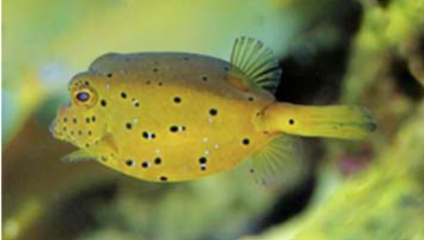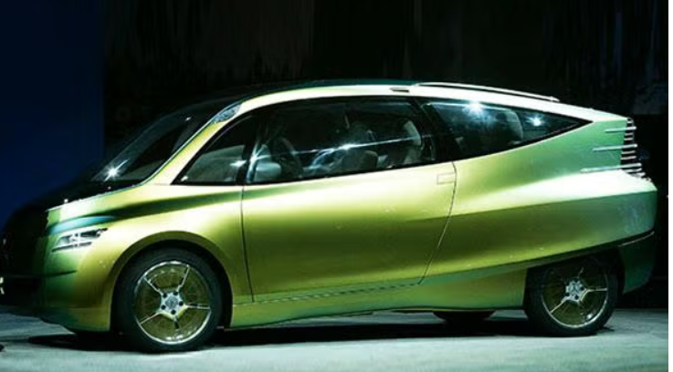

In 2005, Mercedes-Benz unveiled the [Bionic](http://www.daimler.com/dccom/0-5-1276316-1-1525347-1-0-0-1320821-0-0-135-0-0-0-0-0-0-0-0.html), the concept car that resulted from this boxfish-inspired endeavor

June 9, 2005 Bionics, the combination of biology and technology is a recent field of research which has nonetheless already made remarkable progress possible in different areas. Nature has provided ideas for high-strength materials, dirt-repellent coatings and even Velcro fastenings and this has lead to an interdisciplinary project combining biologists and engineers the Mercedes-Benz Technology Center (MTC) to develop the Mercedes-Benz bionic car - a concept vehicle based on examples in nature. Engineers looked for specific example in nature whose shape and structure approximated to their ideas for an aerodynamic, safe, spacious and environmentally compatible car. Using these examples, the team designed and constructed a vehicle with intelligent lightweight construction and extraordinary aerodynamics. The car It was not sleek as the shark or dolphin but a creature that looks anything but streamlined and agile at first sight: the boxfish.

**Shark Skin — Biological Approaches to Efficient Swimming Via Control of Fluid Dynamics**

Background — Sharks are in the class Chondrichthyes, or cartilaginous fish that includes rays,

skates, and others. The dermis is composed of collagen type I fibers organized in helices around the shark’s body in alternating layers that form 50 to 708 angles with each layer between the pectoral and anal fins and 45 to 508 angles in the thin caudal peduncle just in front of the tail. The epidermis is covered with placoid scales called dermal denticles, which are like thousands of teeth embedded in the skin. Unlike the scales of fish, which in most species tend to be broad and flat, placoid scales of sharks are pointed with a basal plate, a pedicel, and a crown enclosure. The denticles vary among species and as sharks age, the number of scales increases. The scales are compared to teeth, given that each is covered by dentine and composed of enamel and have a pulp cavity. Denticles vary widely in size among species. For example, the nurse shark has denticles that are so large and so closely spaced that they can form a barrier against even harpoons. The morphologies vary including blunt, scalloped, spade-shaped, thorn-like, geometric, and heart-shaped. Occasionally, denticles develop independently and become comparatively gigantic structures as in the fin spine, a thorn- like quill, in the spiny dogfish and Port Jackson shark, or the tooth found in the sawfish and the stinger of stingrays.

Mechanism — The roughness of shark skin is paradoxical to principles of fluid dynamics since

rough surfaces increase drag, and shark skin is considered rough due to the denticles. However, the rough texture of shark skin reduces drag due to the presence of microscopic riblets on the surface of the skin. Riblets channel the laminar flow over the skin to further reduce drag after the larger structures, the denticles, create a boundary against turbulent flow. The water is channeled through the small valleys created by the microscopic ridges, speeding up the flow of water over the surface of skin. Without the riblets and denticles, the water would flow over smooth skin and suffer the full effects of friction. The ridges on the denticles, like the ridge that runs longitudinally along the shark’s body, help in drag reduction and in the smoothing boundary layer turbulence. The efficiency of shark skin and shark swimming in water originates in principles of fluid dynamics. Body geometries, movements, and wake evolution have been modeled.

The structure and dynamic behavior of the vortex wakes generated by a swimming body are

responsible for the highly efficiency propulsion and maneuverability. Hydrostatic pressure under the skin of sharks varies with the swimming speed. The stress in the skin varies with internal pressure and this stress controls skin stiffness.

The inertial pressure on sharks increases tenfold between slow and fast swimming. The skin

acts as an external tendon by transmitting muscular force and displacement to the tail. Hydro-

static pressures of 7 to 14 kN m2 occur just under the skin when swimming slowly and with

bending pressure vary between 20 and 35 kN m2 . During bursts of swimming, tighter

bends generate pressures up to 200 kN m 2 . To bend sharply as in fast swimming the muscles

on one side shorten and increase in cross-sectional area, causing the fibers in the skin overlying

the contracting muscles to increase their angle. The changes in fiber angle cause the skin to

remain taut in and avoid wrinkling or loss of tension.

As a variation, some sharks have special arrangements of riblets that converge or diverge in a V pattern on the skin surrounding the shark’s sensory organs. One set angles in toward the shark’s pit organ and others angle away from the lateral-line organ. The function of the pit organ is unclear but the lateral-line organ functions similarly to the human ear. It is suspected

that the diverging riblets draw water away from a shark’s ‘‘ears’’ to prevent the noisy sound of rushing water, which would otherwise inhibit hearing. At the rostrum and on the leading edges of the fins, the skin is almost totally devoid of riblets. This arrangement promotes smooth water flow to each side. If the leading edges of the body and fins were covered by the same denticles as the majority of the body, a swimming shark would deflect the boundary layer away from the body and increase drag. The posterior edges of fins are flexible and denticle-free. This may help to reduce turbulence, saving energy lost to the vortices occurring immediately behind the fins. Three factors affect the drag reducing properties of riblets, sharp-edged riblets,

riblet protrusion height as there is an optimal height for riblets to protrude into the boundary layer beyond which they would interfere with the flow of seawater, and the lateral spacing of the riblets to affect the dynamics of the water passing over the skin (Bechert et al., 1986).

Biomimetics — The structure of shark skin has prompted swimsuit and wetsuit manufacturers

to develop new designs to reduce drag in water to improve times for competitive swimmers or to improve navigation by scuba divers. Properties of shark skin have also been used as models for movements of submersible and surface vessels in order to reduce the drag created by the speed of solid boat structures through water. Finally, aeronautics research has keyed into the structures of shark skin to reduce air resistance for planes. The human’s body with smooth skin covered with hair creates a great deal of drag. Speedo, Inc. has developed a swimsuit for competitive swimmers based on shark skin designs. The Speedo Fastskin FSII suit reduces drag in water by as much as 4%.

Passive drag affects a swimmer in the streamline position, usually after the initial dive into the

water and following a turn. During a 50-m race, a swimmer is likely to be in the streamline position for up to 15 m. Swimmers from more than 130 countries wore this biomimetic suit at the Sydney Olympics and over 80% of the swimming medals and 13 out of the 15 world records set were with swimmers in this new suit. Computational fluid dynamics were used to design the swimsuit which directs water along grooves in the fabric, allowing the water to swirl in microscopic vortices, reducing drag. This control of fluid flow creates greater efficiency in movement and up to 3% improvement in overall speed. A similar design could be applicable to wetsuits to reduce transit time to great depths. Other applications include the design of highly efficient, fast, and maneuver- able underwater craft, and options for pipes in water distribution systems. Lining a pipe with riblet- like grooves speeds flow by up to 10%.

Interest in these general features has also been seen in the aerospace industry for airplane design. In 1997, two Airbus Industry A30 planes were designed to test a specially ribbed plastic film that cuts aerodynamic drag when attached to aircraft surfaces and is expected to decrease fuel consumption by 1% . The riblets are barely perceptible to the touch, and they appear like a matte finish on the aircraft skin. Cathay Pacific and Lufthansa have already begun flying planes with small percentages of their surfaces covered in riblets to test durability.

**Kingfisher beak inspired a bullet train:**

Bullet trains in Japan used to make a loud boom sound when they traveled through tunnels. A bird-watching engineer was able to fix the problem after he was inspired by a kingfisher.

The Japanese Shinkansen [bullet trains](https://interestingengineering.com/video/snow-is-no-match-for-this-japanese-bullet-train) are a miracle of modern engineering. Despite being able to travel at speeds of up to 200 miles per hour (320 kph), they have also proved incredibly safe over their 50-year-plus history. But the early trains came with one major problem: they created sonic booms when they left tunnels. The sound was so loud, it was like standing in a room with a constantly running washing machine. The first issue was determining why the trains were creating this loud boom. Japanese engineers soon discovered it was due to a phenomenon called “tunnel boom.” This is caused by the train pushing air through an enclosed space, like a tunnel, and building up an air pressure wave until it reaches the end of the tunnel. When the train exits the tunnel, just like a bullet from a gun, it generates sound waves of over 70 decibels over an area more than **1,312 feet (400 meters)** away in all directions.

In the case of the “tunnel boom,” nature was, once again, leagues ahead of human beings. Enter the mighty kingfisher.  A small fish-eating bird, the kingfisher hunts its prey by turning itself into a high-speed fishing spear. From a raised perch, this little bird can leap, fall, and penetrate a water body at whim to catch its prey entirely by surprise with little or no splashing.

By studying the bird in detail, one Japanese bird-watching engineer, Eiji Nakatsu, modified the trains to give them their characteristically shaped noses. And, incredibly, it worked. After the changes were made, the Shinkansen’s “tunnel boom” problem evaporated, enabling locals and tourists alike to enjoy the majestic beauty of Japan in peace. It also had other benefits, such as reduced drag, improved fuel efficiency, and increased speed.

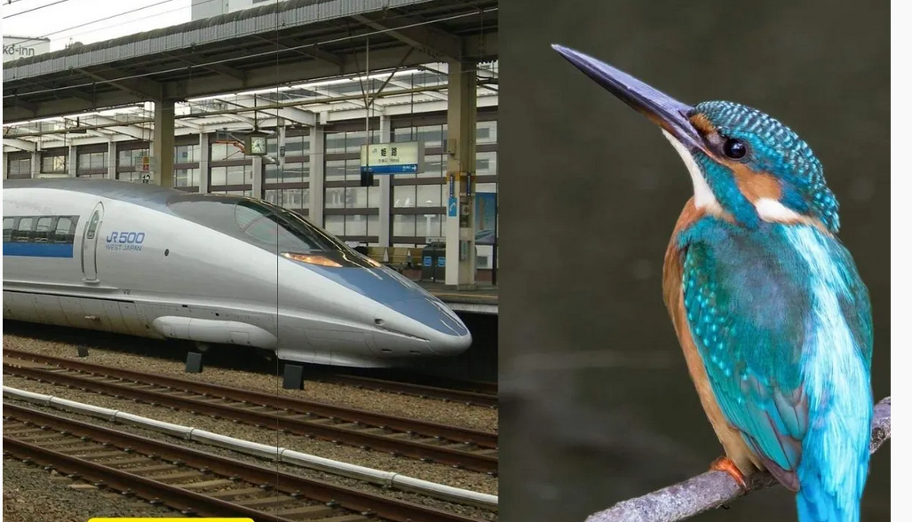

At the turn of the last century, the Japanese bullet train made a deafening sound every time it came out of a tunnel. Technological advances had made it possible to create an incredibly fast but noisy train. This problem dwarfed the achievements of a vehicle that symbolized technical advances.

Fortunately, engineer Eji Nakatu was an animal lover and an active member of the Japan Wild Bird Society. He decided to look for solutions in nature and found them in the kingfisher, a bird that, due to its shape, encounters little resistance when submerged in water.

After carrying out several tests, the results proved him right: imitating the shape of the kingfisher reduced the noise of the bullet train while significantly increasing its speed and aerodynamics.

**Coral – Celera Cement:**

In terms of the infrastructure construction near coral reefs, native coral aggregates have been widely implemented as alternative efficient building materials to prepare the “coral concrete”, Coral aggregates (CA) have similar chemical characteristics to cement. Concrete is a fundamental component that is regularly utilized in the construction of buildings. Concrete is made up of cement, aggregates, chemical and mineral admixtures, and water and contains a large proportion of artificial components. The amount of concrete consumed on our entire Planet is measured in billions of tons. The extensive use of concrete in the building has increased the demand for concrete materials, resulting in large-scale mining for raw materials. The consequences of this condition include a decline in the availability of materials such as cement for concrete production, which is directly proportionate to the increase in costs and material shortages. Coral debris is primarily formed of coral reef alga and marine species bone debris . It is the result of channel digging and harbor dredging, as well as natural weathering, which take up valuable island space and have a detrimental effect on ecological systems. As a result, maximizing the utilization of this coral debris is necessary to meet the marine industry’s material requirements.

Coral aggregates (CA) are a type of undersea environment comprised of coral invertebrates that produce a calcium carbonate structure, a form of limestone. CA is typically composed of limestone, which means that the aggregates formed from coral have the most chemical content in the form of CaCO3, which is classified as limestone. CA may be used in the replacement of fine aggregate in concrete as a substitute ingredient. By and large, CA is composed of limestone. This is because these rocks contain a high concentration of CaO. Geologically defined, limestone-containing rock is also referred to as crystalline limestone. Meanwhile, coral reefs degrade when they are damaged. As a result, this form of rock is known as coral limestone . CA is formed when coral reef-building organisms deposit vast amounts of calcium carbonate (CaCO3). Calcium carbonate (CaCO3), which contains a similar chemical composition to cement, can be used in place of some of the cements in concrete.

The extensive usage of rock fragments as a cement substitute will affect the chemical composition of cement . When used with cement, CA can enhance the binding capacity by acting as a more homogenous binder throughout the hydration process. CA can be used as a common aggregate; however, it is light and porous, with a rough surface, lack of adhesion, and high sea salt concentrations. These parameters affect the resulting workability, mechanical capabilities, volume stability, and durability of concrete . Numerous researcher findings indicate that the CA used to replace a portion of the conventional aggregates has physical qualities similar to river aggregates.

**Morpho Butterfly - Structural Colors:**

Structural color is caused by wavelength-selective scattering of light by microscopic features, such as those on the scales of some insects. The brilliant blue displayed by some male *Morpho* butterflies is a classic example of this phenomenon. The Blue Morpho butterfly exhibits a brilliant, [iridescent](https://www.uvm.edu/~dahammon/Structural_Colors/Structural_Colors/Definitions.html) blue wing color.

What kind of structures could produce the iridescent blue color of the wings?

The color is caused by structures that are  hundreds of nanometers [[100 nm](https://www.uvm.edu/~dahammon/Structural_Colors/Structural_Colors/100_nm.html) = 1,100 S/D] in size.

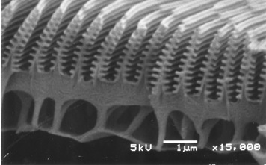

These structures are are arranged in rows which behave in the same manner as a [diffraction grating](https://www.uvm.edu/~dahammon/Structural_Colors/Structural_Colors/Diffraction_And_Interference.html). These structures also form a [multilayer](https://www.uvm.edu/~dahammon/Structural_Colors/Structural_Colors/Definitions.html) which causes the blue wavelengths of light to [interfere constructively](https://www.uvm.edu/~dahammon/Structural_Colors/Structural_Colors/Diffraction_And_Interference.html).  This is depicted below where a simple model   shows the blue wavelengths being reflected of successively deeper  layers.  This is called multilayer thin film interference.  Longer wavelengths, such as red light, interfere in a destructive manner with this structure.

Structural colour in the *Morpho* butterfly originates from submicron structure within a scale and, for over a century, its colour and reflectivity have been explained as interference of light due to the multilayer of cuticle and air.

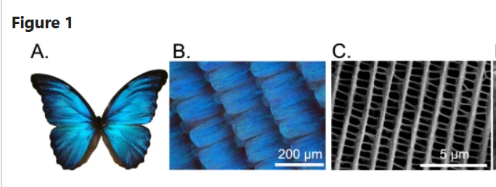

Structural coloration and wing composition of the *M. didius*. The blue coloration caused by the surface micro-/nano-structures is shown for a specimen of a *M. didius* in (**A**). The blue colored scales of the *M. didius* are presented in (**B**). A scanning electron microscope (SEM) image in (**C**) illustrates the arrangement of the *M. didius* ridges on a single wing scale.

**Principles of the Morpho-color**

The brilliant blue color of some *Morpho* butterflies has long been an important research subject . The color is produced by the wing scales, which are composed of nearly transparent cuticle proteins. The principle of this phenomenon has been referred to as grating or multilayer, which also explains the high reflectivity of the blue coloration. This blue luster is not affected by chemical change and lasts for more than 100 years (the structural color can be found even in fossils.

Multilayer grating structures, such as those found on the wings of the Morpho butterfly are able to interact with light to generate structural coloration. When illuminated and viewed at defined angles, such structural color is characterized by exceptional purity and brightness. To provide fur-ther insight into the mechanism of structural coloration, two-photon laser lithography is used to fabricate bioinspired bigrating nanostructures, whose optical properties may be controlled by variation of the height and period of the grating features.

**Bioinspiration from Morpho butterflies** is design of the color material and the fabrication process. One of the most well-known examples of direct biomimetic applications is adding luster to fibers. The color of the resulting textile material is derived from the multilayer interference of the Morpho butterfly, and this is the first application of the Morpho butterfly’s coloration.

**Namib Beetle for water collecting**

The cold Benguela current runs along the South West African coast, creating one of the most arid habitats on earth; the Namib Desert. Water is essential to all living organisms and this harsh environment presents a major challenge for all life forms. However, the cold coastal current not only suppresses rainfall over the desert, but is also the origin of fog that can reach as much as 100 km inland from the coast. Fog brings water in the form of minute droplets that can deposit up to a litre of water per square metre on the mesh of an artificial fog screen during a day in the Namib Desert. These fog events occur approximately 30 days per year in the inland desert, and represent a predictable source of water for the Namib Desert organisms.

The Namib Desert has a remarkably high variety of Darkling beetles and a handful of them actively exploit fog for water intake. Some of these beetles construct sand trenches or ridges to catch the fog, while Namib beetle instead utilise their own body surface as a fog water collector . By adopting a head standing posture facing into the wind, the fog water collects on their elytra and runs down to their mouth, to be imbibed by the beetles. This unique behaviour is termed fog-basking. The advantage of fog collection for water intake in the extremely arid desert is obvious, and becomes critical when rainfall is absent over prolonged periods of time. Long term studies on the population density of Darkling beetles in the Namib Desert clearly shows that the fog collecting beetles are still present in great numbers during periods of

low rain fall, whereas the large majority of Darkling beetles that lack this adaptation disappear or decline to less than 1% of their mean abundance. The mechanism by which fog water forms into large droplets on a beaded surface The structures behind this process are

believed to be hydrophilic peaks surrounded by hydrophobic areas; water carried by the fog settles on the hydrophilic peaks of the smooth bumps on the elytra of the beetle and form fast-growing droplets that – once large enough to move against the wind - roll down towards the head.

**The bumps are hydrophilic (water loving) and the channels are hydrophobic (water fearing), working in tandem to harvest water from the air**. The hydrophilic bumps accumulate droplets of moisture from the air, then the beetle leans forward and the hydrophobic channels allow it to drip into its mouth. shape and texture of the beetles increased the amount of water droplets they could capture from the air

Shortage of water resources and deterioration of water quality are becoming more and more serious today. Inspired by Namib Desert beetles, scientists designed biomimetic fog collection materials to obtain fresh water. The overview of this field is limited and mainly concerned with the preparation and application. In this paper, we focused on the water collection efficiency of surfaces inspired by beetles and discussed their influence on the water collection efficiency from three aspects: surface wettability, surface structure and surface pattern distribution.

Fog harvesting of the Namib desert beetles has inspired many researchers to design artificial fog harvesting hybrid surfaces, which commonly involve flat hydrophilic patterns on hydrophobic surfaces.

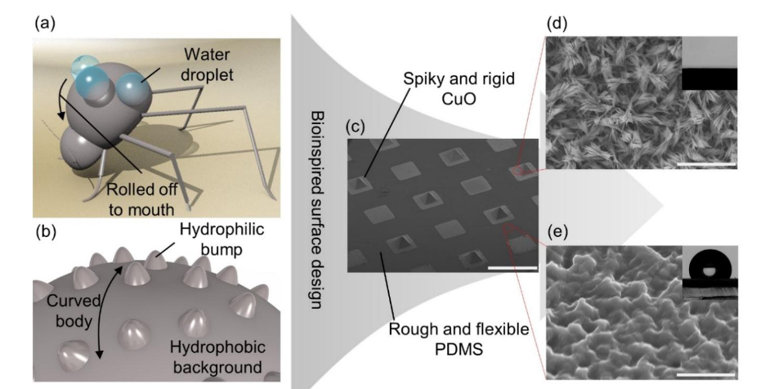

**Figure.** A schematic overview of the bioinspired hybrid surface. (a) A cartoon of a fog harvesting beetle. (b) A cartoon of the magnified dorsal surface of a beetle. (c) A scanning electron microscope (SEM) image of the fabricated flexible hybrid surface. The scale bar indicates 1 mm. (d) A magnified SEM image of a CuO region. The inset is a spread water droplet on it. The scale bar indicates 5 μm. (e) A magnified SEM image of a rough PDMS surface. The inset is a water droplet on it.

**Bioinspiration:** The improved fog collector was constructed by a superhydrophobic-superhydrophilic patterned fabric via a simple weaving method, followed by in-situ deposition of copper particles. Compared with the conventional fog collector with a plane structure, the fabric has shown a higher water-harvesting rate at 1432.7 mg/h/cm², owing to the biomimetic three-dimensional structure, its enhanced condensation performance enabled by the copper coating and the rational distribution of wetting units.

**Termite Mould passive cooling:**

The airflow in building environment is a strategy that could provide indoor thermal comfort conditions in warm and dry environment. Therefore, formation of ventilation inside buildings is essential. Termite mounds are stable natural structures found in desert areas and have fascinated researchers for more than two centuries .One source of this fascination is the adaptability of termite mounds with their environment throughout different seasons, which is achieved with minimum energy consumption and only on account of good architectural design of structure.

The climate of Harare, Zimbabwe usually requires buildings to be cooled year-round. This means the purchase, installation, and maintenance of a traditional air-conditioning system for a building has immediate and long-term costs. The challenge was to create a self-regulating ventilation system that would keep a building at temperatures that are comfortable for workers and residents.

**Innovation Details**

The Eastgate Centre is a shopping center and office building located in Harare, Zimbabwe. Rather than using a traditional fuel-based air-conditioning system to regulate temperature within the building, the Eastgate Centre is designed to exploit more passive and energy-efficient mechanisms of climate control. The building’s construction materials have a high thermal capacity, which enables it to store and release heat gained from the surrounding environment. This process is facilitated by fans that operate on a cycle timed to enhance heat storage during the warm daytime and heat release during the cool nighttime. Internal heat generated by the building’s occupants and appliances also help to drive airflow within the building’s large, internal open spaces, as it rises from offices and shops on lower floors toward open rooftop chimneys. Various openings throughout the building further enable passive internal airflow driven by outside winds. These design features work together to reduce temperature changes within the building interior as temperatures outside fluctuate. The $35 million building saved 10% on costs up-front by not purchasing an air-conditioning system. Rents are less expensive in this building compared to nearby buildings because of the savings in energy costs.

At the time of the building’s design, researchers had proposed that termite mounds maintained stable internal climates by having a physical structure that enables passive internal airflow. While subsequent research on termite mounds has altered our understanding of the function of mound structures, the Eastgate Centre still achieves a controlled internal climate with the help of cost-effective and energy-efficient mechanisms originally inspired by termite mounds. 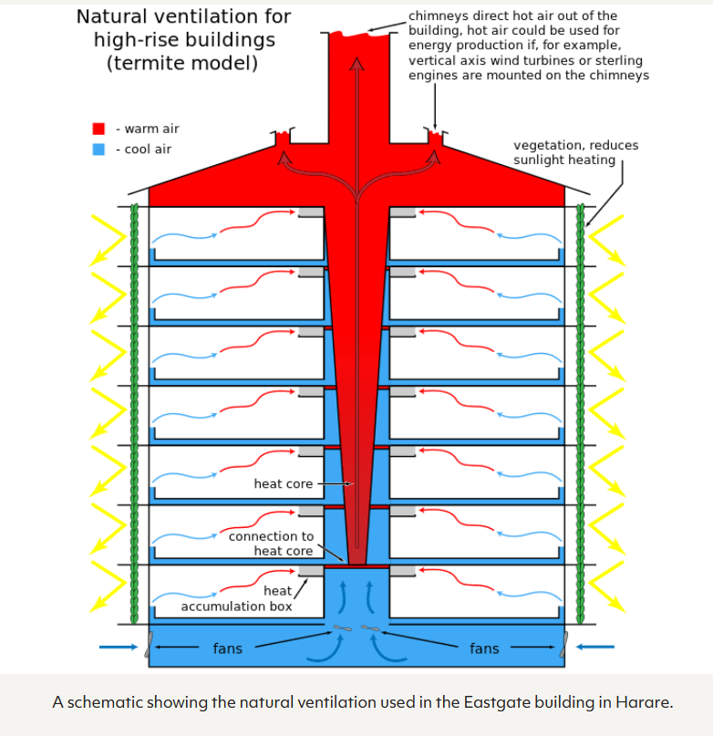

A schematic showing the natural ventilation used in the Eastgate building in Harare.

**Biological Model**

It was previously thought that termite mounds functioned to continuously maintain the nest’s internal temperature within a narrow range in the face of extreme outside temperature fluctuations. However, the most recent published research on termite mounds suggests that they function much like mammalian lungs and act as accessory organs for gas exchange in the underground nests. During the day, changes in internal nest temperature are less extreme than changes in outside temperature, but over the course of a year, nest temperature does vary and closely follows the temperature of the surrounding soil.

**Microneedles inspired by mosquitos**

Microneedles have evolved over recent years as a replacement for traditional hypodermic needles to minimize pain during transdermal drug delivery (TDD) or during blood draw for clinical analysis. Female mosquitoes have offered scientists an excellent insight into how an organism has evolved to drive a flexible microneedle into human skin and draw blood without causing pain to the host. Microneedle designs inspired by the anatomy of a mosquito fascicle and the mechanics of feeding by female mosquitoes have been developed by several researchers.

A microneedle is able to penetrate the skin painlessly when the critical load applied by it is greater than the load required to puncture the skin and the microneedle does not buckle. Once inserted, the microneedle draws blood or delivers therapeutic agents quickly into the blood stream.

**The mosquito inspired needle** is a new type of hypodermic needle would make injections a less agonising experience. The biggest difference between a regular needle and a mosquito inspired one is the fact that the edge is not smooth. It’s jagged. Immunisations currently prevent between 2 and 3 million deaths every year, however, a change to the design of needle used could prevent even more deaths.

The fact that mosquitos are able to puncture the skin without causing pain is amazing. They are able to do this due to their use of saliva to numb the feelings, as well the vibration of the fascicle, which is the part of the mosquito that draws the blood. The jagged edges on the proboscis or the mouth like part help to reduce the pain. But the most interesting part of the mosquito’s action of drawing blood is the fact that the proboscis of the mosquito actually varies in stiffness. It gets softer near the tip reducing the force required to pierce the skin, causing less deformation and therefore less pain.

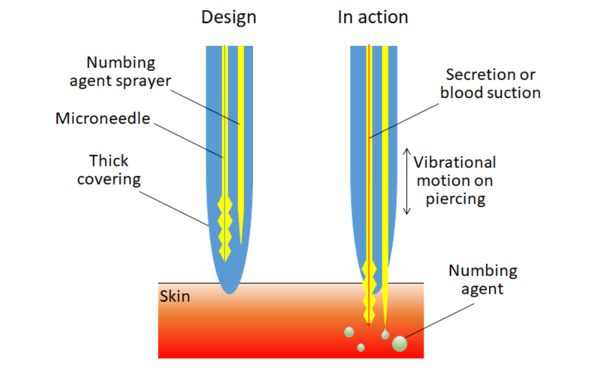

**Biomimicry**

The mosquito punctures human skin to draw blood without the human even knowing it is happening. They do this using three techniques. First, upon insertion, they secrete numbing saliva. Second, the fascicle, or part that draws blood, vibrates when piercing the skin, reducing the force inflicted on the human. And third, the mosquito’s “needle” is serrated, which also, counterintuitively, makes the insertion easier and less painful for the human.